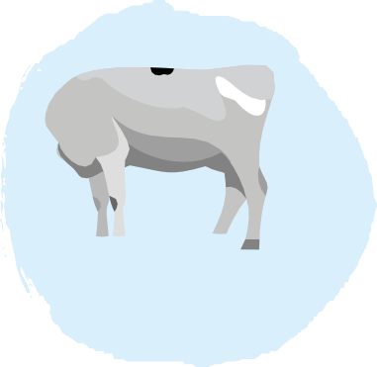






Dear Parent 8th July 2026

If you wish to order milk from September 2026, please find below a guide on how to do this. The price for this for the full Autumn term will be £25.20 or £12.96 for the first half term and £12.24 for the second half term. (This is subject to change).

Please visit our website www.dairylink-uk.com .

- You will need to click on the 'order milk' tab, register with us, add your child/children on the 'children' tab. (Please check your spam folder should you not receive your confirmation email).

OVER 5 CHILDREN – Please choose the start date of 31st August 2026
- Click on the 'payments' tab and you can then select as many terms or half terms as you wish to pay.

UNDER 5 CHILDREN – Please put the start date in that your child starts to school
- Please input their date of birth and the system will take the order without paying for the milk. PLEASE NOTE THAT THIS WILL NEED TO BE PAID FOR FROM MONDAY OF THE WEEK OF THEIR 5TH
BIRTHDAY. You will need to order the milk by Monday 1pm the week before the free milk expires.

FREE SCHOOL MEALS CHILDREN
- If your child receives free milk under the FSM scheme then please contact the school, you do not need to register online.
- ALL CHILDREN - Please ensure you enter the correct class/year that your child is in and you need to enter your child’s new class if they have moved up.

The timeline for the milk order is between Monday 13th July and Monday 24th August at 1pm. After this time, the system will stop receiving orders for w/c Mon 1st Sept, and you will not be able to get milk for that week. Therefore, please make sure you order by this date and time. The system works by ordering before Monday 1pm which would then ensure your child has milk for the following Monday onwards (i.e. a week later). If you miss the Monday (24th August) deadline, your child’s milk won’t be added for a week after the oncoming Monday, so if you order on a Tuesday, for example say Tuesday 25th August, your child’s milk will start on Monday 8th September. PLEASE DO NOT TRY TO ORDER FOR SEPTEMBER BEFORE MONDAY 13TH JULY AS YOU WILL BE CHARGED FOR MILK IN THE CURRENT TERM.

If you need anything further, please contact Stephanie at stephanie.griffiths@dairylink-uk.com or on 01785 286823.

Yours sincerely

Barbara Griffiths DairyLink UK Ltd

DairyLink UK Ltd
Part 1st and 2nd Floors, 64 High Street, Stone, Staffordshire, ST15 8AU
Call: 01785 286823
Email: stephanie.griffiths@dairylink-uk.com



